Online Renewal Process
Go to CNPWebOnlineLogin (hold down the control key and click on link to open)
- Log in using your assigned CNP Web login and password
- Click on Program Code SNP for Student Nutiriton Program
- Select the current program year

STEP 1: Go to the Applications Tab
- Sponsor Info Sheet – click on the “+” sign to open up the Sponsor Info Sheet. Update contact information – Note: at least two contact names, with current contact information, are required.
  - Site Info Sheet(s) – click on the “+” sign to open up Site Info Sheets.
- Check all months that you will be submitting a claim for reimbursement. You may combine the months of August and September’s claims if you have less than 10 operating days in August.
- October/Baseline data is your free and reduced price meal eligibility count from last October. F&R Eligibility and Access Tabulation - Education and Early Development (hold down the control key and click on link to open)
  - You will have to open this report in full-screen view and use the bar at the bottom to scroll page over to find your numbers. See pictures on next page for help on opening up to a full-screen view.
- Check program participation and enter meal prices charged (if any) for each meal category.
- Complete menu planning and collection procedures
- Check Submit when all fields are complete.
  - CEP Districts Note: The CEP section is completed at the State Level – so you will get an error message at this time!

STEP 2: Fill out required forms on both CNP Web and Smartsheet (see link on checklist sheet)
For CNP Web:
- Download, complete and save a copy of all off-line forms applicable to your district. Save as PDF.
- Upload completed copy of forms back into the CNP web checklist tab using the upload function.
- Choose the Upload symbol at bottom of the Checklist Tab when Steps 1 & 2 are complete to Submit On-Line application to SA for approval.

If you have questions or need help, call or email
Rachel Negron 907-269-9867 eed.cnp.schoolmeals@alaska.gov
Rachel Spencer 907-269-6578 eed.cnp.schoolmeals@alaska.gov
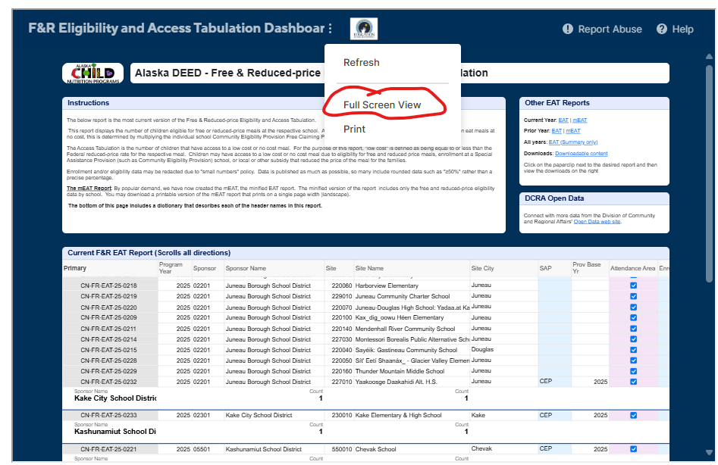
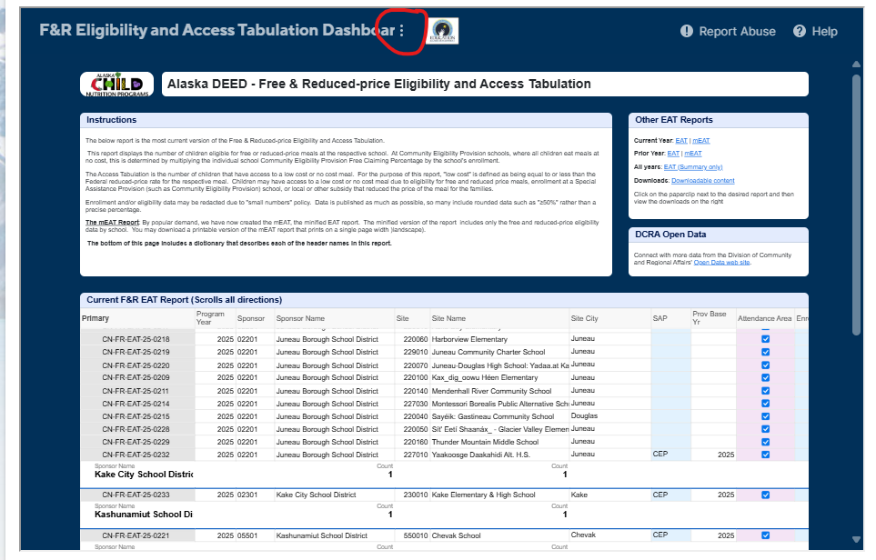

Application Documents

This is a reference document for what will be necessary for your CEP and Non-CEP applications and where to find them/upload.

CNP Form Submission Studio - Smartsheet.com (hold down the control key and click on link to open)

Document |  | Location | Optional/Required
 | Claim Override Request | Smartsheet | Optional
 | Community Eligibility Provision Election | Smartsheet | Required for CEP Only
 | Food Safety Inspection Report | Smartsheet | Required for Both
 | Meal Pattern Compliance Attestation | Smartsheet
 | Paid Lunch Equity Report | Smartsheet | Required for Non-CEP
 | Permanent Free & Reduced-Price Policy Statement | Smartsheet | Required for Both
 | Onsite Counting and Claiming Review Summary | Smartsheet | Required for Both – individual upload
 | Unanticipated Site Closure | Smartsheet | Optional
 | Fluid Milk Waiver | Smartsheet | Optional
 | Meal Time Waiver | Smartsheet | Optional
 | Technology in Lieu of Conforming Official | Smartsheet | Required for certain school districts, call your SNP team to clarify.
 | Food Safety Inspection Request Letter | CNP Web | Required for Both
 | CEP Parent Letter-SFA sample | CNP Web | Required for CEP Only
 | Sample Notice of Application Verification Letter to Parent/Guardian | CNP Web | Required for Non-CEP
 | Sample of Application Verification Results Letter to Parent/Guardian | CNP Web | Required for Non-CEP
 | Sample of Approval/Denial of Benefits Notification | CNP Web | Required for Non-CEP
 | Sample of Direct Certification Notification | CNP Web | Required for Non-CEP
 | 2025-2026 Household FR Application | CNP Web | Required for Non-CEP
 | RCCI Eligibility Policy Statement | CNP Web | Only required for RCCI
 | Vended Meal Agreement | CNP Web | Required for certain school districts, call your SNP team to clarify.
 | FSMC Checklist (Only for sponsors with vended meal programs) | CNP Web | Required for certain school districts, call your SNP team to clarify.
 | On-Site Counting and Claiming for Afterschool Snack (ASP) | CNP Web | Required for districts participating in ASP
 | On-Site Review for School Meals Counting & Claiming-ADA | CNP Web | Required for Both – Form for bulk upload
 | On-Site Counting and Claiming Review Summary - Submission Instructions | CNP Web | Required for Both
 | CNP Medical Statement-ADA.pdf | CNP Web | Optional

Household Application and/or Letters with Alterations
- Application is clear and simple in design and the information requested is limited to the required data - household does or does not meet the eligibility criteria, and in a language that parents and guardians can understand.
- Application contains income information for each HH member identified, and the source of income (such as earnings, wages, welfare, pensions, support payments, unemployment compensation, social security, PFD, and other cash income).
- Application must require applicants to provide the names of all HH members. To include the last four digits of the social security number of the adult household member who signs the application. If the adult member signing the application does not possess a SS#, the household must so indicate.
- Application must be signed by an adult member of the family.
- Application must contain clear instructions regarding the submission of the completed application to the LEA to determine eligibility. A HH must be allowed to file an application at any time during the school year. A HH may, but is not required to, report any changes in income, household size or program participation during the school year.
- Required Statements:
- “The Richard B. Russell National School Lunch Act requires information on this application. You do not have to give the information, but if you do not, we cannot approve your child for free or reduced-price meals. You must include the last four digits of the SS# of the adult HH member who signs the application. The last four digits of the SS# are not required when you list a SNAP, TANF, FDPIR case number or other FDPIR identifier for your child or when you indicate that the adult HH member signing the application does not have a SS#. We will use your information to determine if your child is eligible for free or reduced-price meals, and for administration and enforcement of the lunch and breakfast programs. We MAY share your eligibility information with education, health, and nutrition programs to help them evaluate, fund, or determine benefits for their programs, auditors for program reviews, and law enforcement officials to help them look into violations of program rules.”
- “Foster, migrant, homeless, and runaway children, and children enrolled in a Head Start program are categorically eligible for free meals and free milk. If you are completing an application for these children, contact the school for more information.”
- Application must include a non-discrimination statement.
- Application must include EEO Statement – This institution is an equal opportunity provider.
- Application must include a statement, immediately above the space for signature, that the person signing the application certifies that all information furnished in the application is true and correct, that the application is being made in connection with the receipt of Federal funds, that school officials may verify the information on the application, and that deliberate misrepresentation of the information may subject the applicant to prosecution under applicable State and Federal criminal statutes. “I certify (promise) that all information on this application is true and that all income is reported. I understand that this information is given in connection with the receipt of Federal funds, and that school officials may verify (confirm) the information. I am aware that if I purposely give false information, my children may lose meal benefits, and I may be prosecuted under applicable State and Federal laws.”
- Applicants must attest to changes in information if changes are voluntarily reported in writing during the eligibility period.
- Application must include a section to certify or deny children as eligible for free meals or free milk.

